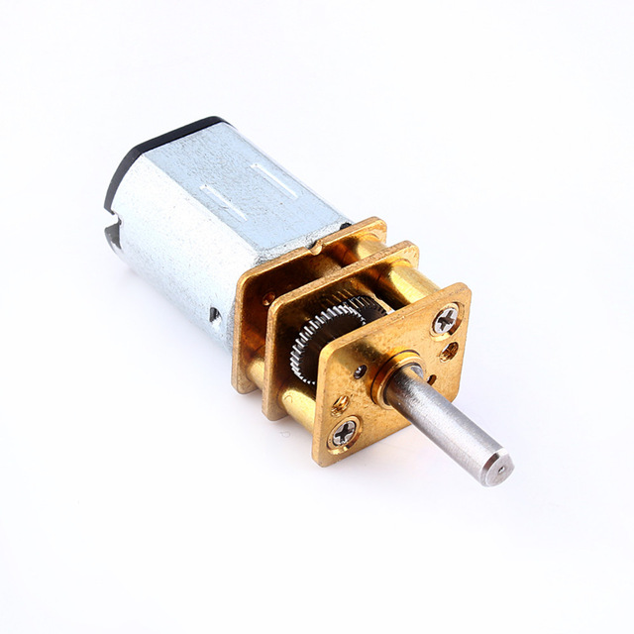
24/10/17
- Started looking at motors which will turn the sides of the cube (https://www.aliexpress.com/item/DC-6V-12V-50-300RPM-Gear-Motor-Speed-Reduction-Gear-DC-Motor-Electric-Gear-Box-with/32821679631.html?spm=2114.search0204.0.0.NZDYjp)

- Started desigining the core of the cube using OpenSCAD
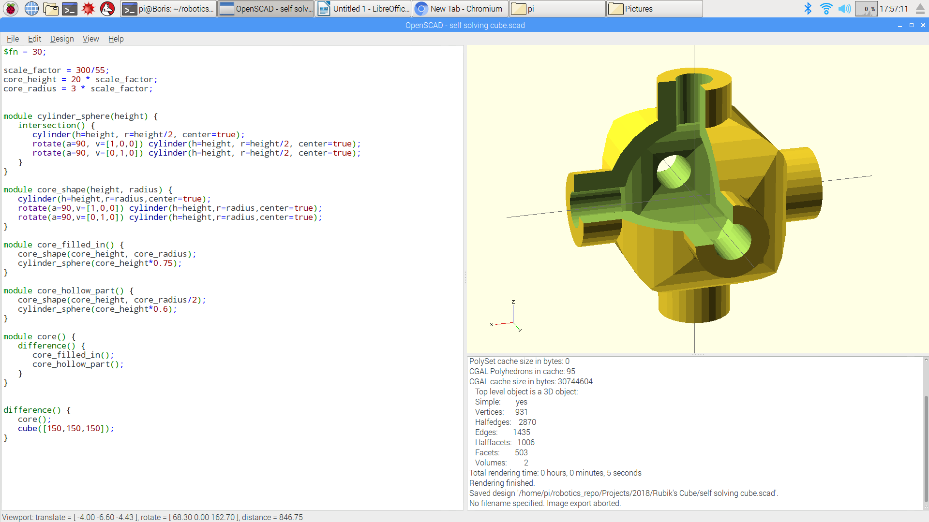

27/10/17
- Started thinking about and discussing design features / specifications for our 3d printer (which we will use to print the cube).
03/11/17
- Decided that the cube will have removable tiles on each face and started working on the design for this.
07/11/17
- Designed the tile and cut out the tile pieces from the centres, edges and corner pieces so we can print them separately (and coloured) to fit into the cube pieces.

